RECIPE NAME: ..........................................................................................................................

CHEF’S BIO:

PICTURE HERE

…………………………………………………

…………………………………………………

…………………………………………………

…………………………………………………

…………………………………………………

Chef Name: Serves: Prep time: Cook time:

INGREDIENTS
…………………………………………………

…………………………………………………

…………………………………………………

…………………………………………………

…………………………………………………

…………………………………………………

…………………………………………………

…………………………………………………

…………………………………………………

DIRECTIONS
………………………………………………………………

………………………………………………………………

………………………………………………………………

………………………………………………………………

………………………………………………………………

………………………………………………………………

………………………………………………………………

………………………………………………………………

………………………………………………………………

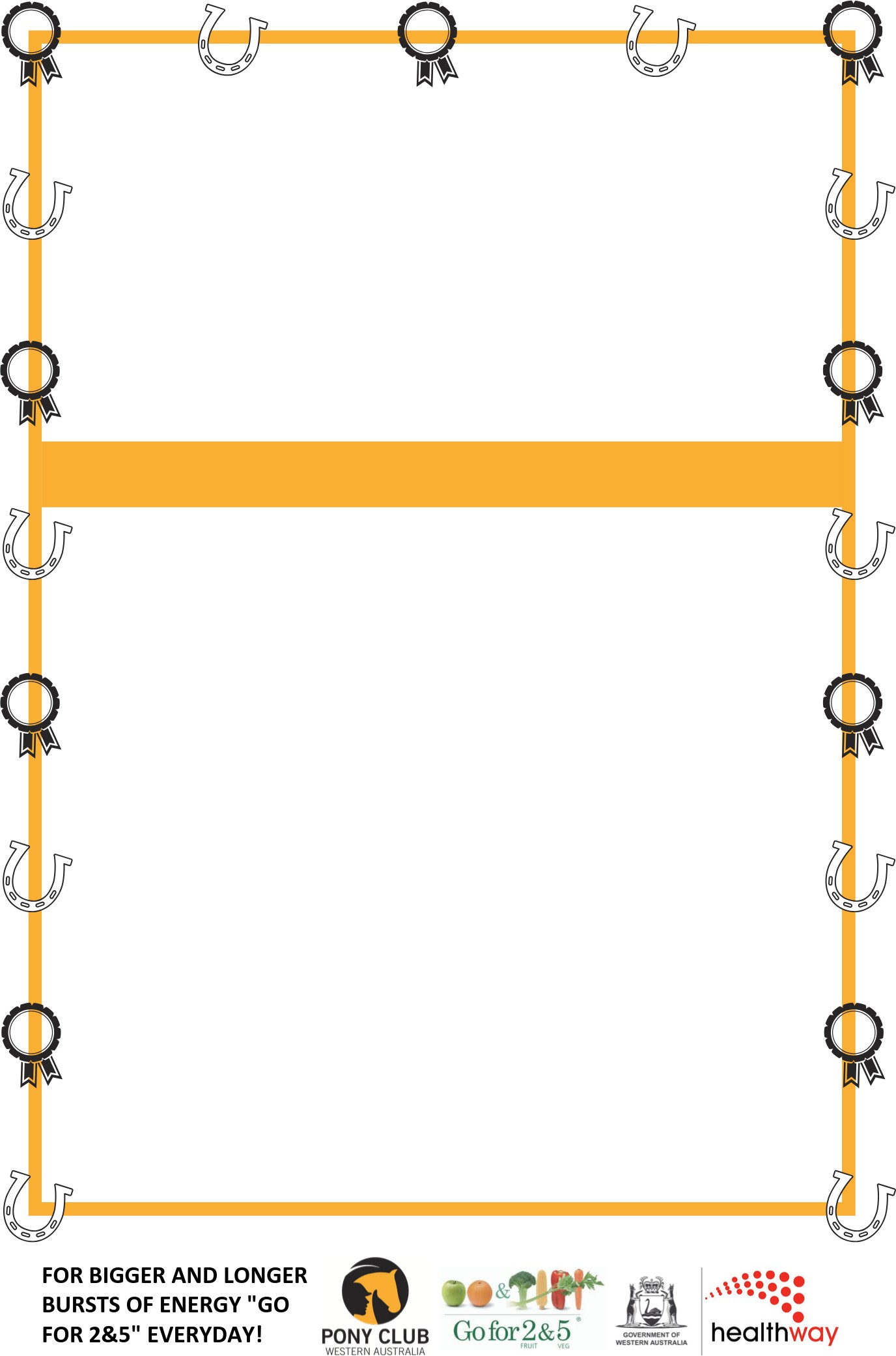
Why is this recipe special to you?

What’s in it that’s healthy and why?

